AN ANALYSIS OF THE DOCTOR DEFICIT PROJECTION IN GERMANY IN NEXT 20 YEARS

What does this mean for Africa?

**1.0 Task Overview**

Based on population trends, retirement age, graph out the doctor deficit in Germany over the next 20 years. Calculate what it would mean for Africa.

**2.0 Data Collection**

Based on the task requirements, data was sourced and collected for the below:

* ***Doctors in Germany***: The dataset includes the number of practicing doctors and those without medical activity from 2019 to 2023.

* ***Mean Retirement Age***: This includes retirement age data over the years, with different categories such as standard age and various other special cases.

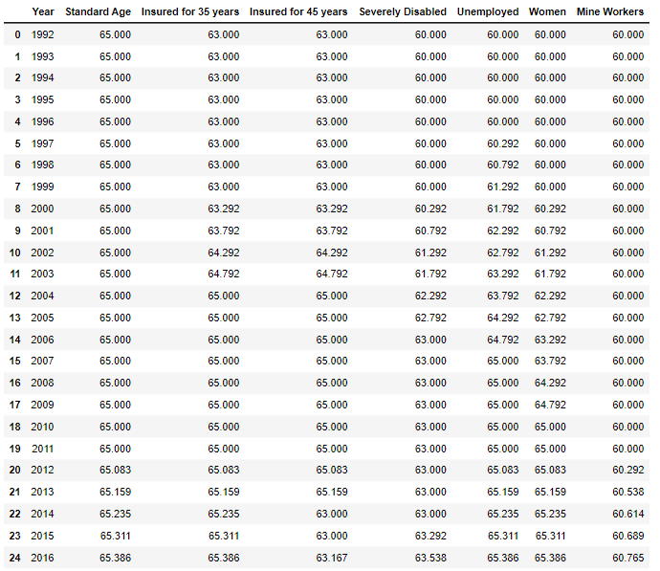

* ***Labour Force***: Contains data on Germany's labor force, including employment figures.

* ***Germany Population***: Population data from 1960 to 2024.

* ***Population Projection by Age Group***: Projects population by age groups from 2021 to 2070.

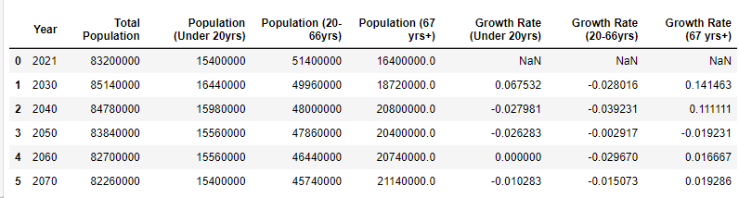

* ***Age Distribution:*** Percentage distribution of age groups in Germany from 2019 to 2023.

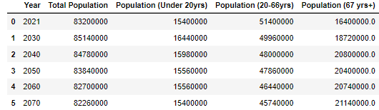

* ***Number of Medical Graduates:*** Number of medical graduates from 2002 to 2021.

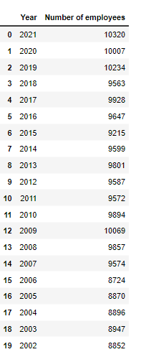

**3.0 Summary of Data Analysis Performed**

* Raw data was collected from various sources and loaded into our Jupyter notebook.
* Data exploration followed to understand the different raw data collected such as their structure and content.
* **Population Growth and Aging Trend**: Analysis was performed, and visuals created to showcase trend. Calculated growth rates for different age groups in the raw data and displayed the updated dataframe with growth rates.
* **Estimating the Supply of Doctors**: Used linear regression to project the number of practicing doctors for the next 20 years. Created a dataframe with the projected number of doctors.
* **Forecasting the Demand for Doctors**:
  + Interpolated population projections for each year from 2021 to 2051.
  + Calculated the ratio of doctors to the total population and the elderly population.
  + Projected the demand for doctors based on the aging population.

1. **Calculating and Visualizing the Doctor Deficit**:
   * Merged the supply and demand projections to calculate the doctor deficit.
   * Visualized the projected supply, demand, and deficit of doctors using a line plot with a shaded area indicating the deficit.

**4.0 Key Insights**

1. **Doctor Supply**: According to the "Doctors in Germany" data, there has been a steady increase in the number of practicing doctors in Germany over the years. In 2023, there are approximately 428,500 practicing doctors, up from 301,000 in 2002 and that figure is expected to grow steadily in the coming years.

1. **Retirement Age:** The "Mean Retirement Age" data shows that the standard retirement age in Germany is projected to remain at 65 - 67 years over the next two decades. However, there are variations for different insured periods and specific occupations.

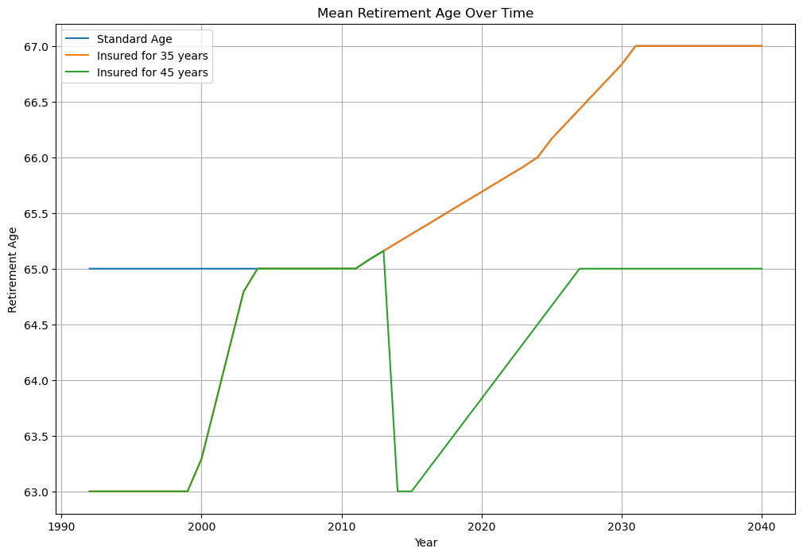

1. **Population:** Germany's population has been growing and is projected to continue growing, reaching approximately 85 million by 2040, according to the "Population Projection by Age Group" data collected.

1. **Medical Graduates:** The number of medical graduates has fluctuated over the years, with a recent increase to 10,320 in 2021.

**5.0 Results and Graph:**

* **Projected Number of Doctors**: The supply of practicing doctors is projected to increase, but not at a rate sufficient to meet the growing demand considering a lower number of new medical graduates entering the workforce.

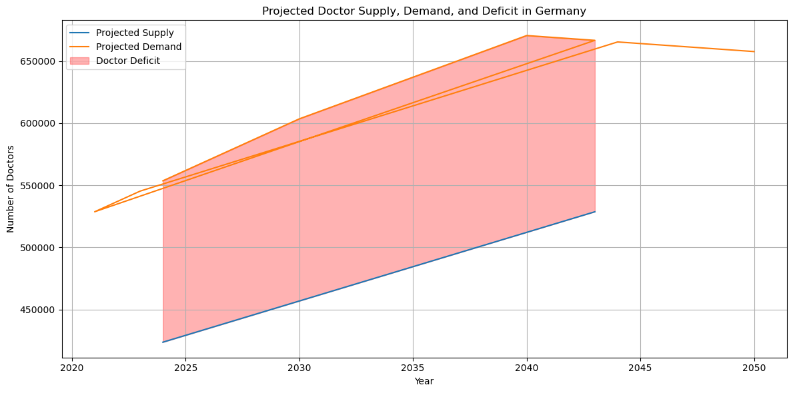

* **Projected Demand for Doctors**: The demand for doctors is expected to increase due to the aging population, particularly the increase in the population aged 67 and above.
* **Population Aging:** The aging population is a major factor driving the increased demand for doctors, particularly those aged 67 and above projected to increase in the next 20 years.

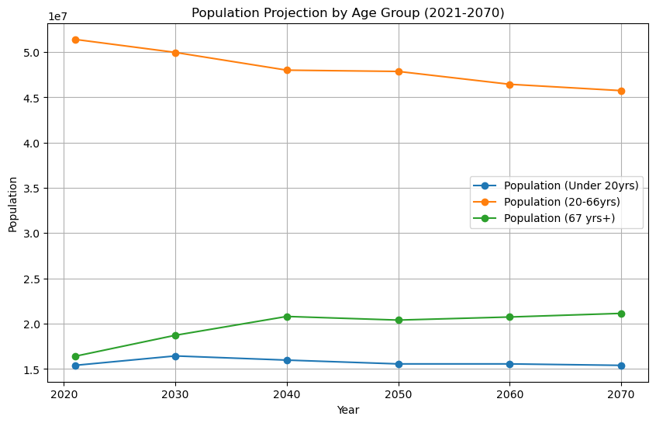

* **Doctor Deficit Projection:** The analysis shows a growing deficit in the number of doctors, with the demand outpacing the supply. There is a significant projected deficit of doctors in Germany over the next 20 years, with the deficit increasing each year. This deficit is visualized in the graph, where the area between the projected supply and demand lines represents the doctor deficit.

This analysis highlights the need for strategic planning to address the anticipated shortage of doctors in the coming years.

**6.0 Implications for Africa:**

The doctor deficit in Germany may have implications for Africa, particularly in terms of brain drain and healthcare disparities:

**Brain Drain:** The doctor deficit in Germany could lead to increased recruitment of doctors from African countries, exacerbating the existing brain drain of healthcare professionals from the continent. This could further strain healthcare systems in Africa.

**Healthcare Disparities:** The projected doctor deficit in Germany highlights the contrasting situation in many African countries, where there is already a critical shortage of healthcare workers. This disparity in access to healthcare between developed and developing nations may widen.

**Collaboration and Investment**: Addressing the global imbalance in healthcare worker distribution will require international collaboration and investment in healthcare infrastructure and education in Africa.

In conclusion, the data suggests that Germany is facing a potential doctor deficit in the upcoming years, and this could have significant implications for Africa in terms of brain drain and healthcare disparities. To fully analyze the impact on Africa, further data on healthcare worker migration patterns, healthcare infrastructure, and country-specific demographics in Africa would be necessary.

**7.0 References**

1. Vanella, P., Rodriguez Gonzalez, M. and Wilke, C. B. (2022) “Population Ageing and Future Demand for Old-Age and Disability Pensions in Germany – A Probabilistic Approach”, Comparative Population Studies. Wiesbaden, Germany, 47. Available at: <https://doi.org/10.12765/CPoS-2022-05> (Accessed 21 August 2024)
2. Statista (2024). Number of doctors in Germany from 1990 to 2023. Available at: <https://www.statista.com/statistics/582114/doctors-in-germany-number/> (Accessed 23 August 2024)
3. World Bank Group (2024) Data | Population, total. Available at: <https://data.worldbank.org/indicator/SP.POP.TOTL> (Accessed 21 August 2024)
4. Worldometer (2024). Countries in the world by population (2024). Available at: <https://www.worldometers.info/world-population/population-by-country/> (Accessed 24 August 2024)